Intro to the Soar Debugger in Java

Overview
With Soar 8.6 we have a new method for interfacing into Soar based around SML (Soar Markup Language). This interface allows tools to be built that have a higher level understanding of the data being sent back and forth to the Soar kernel and allows for more dynamic debugging sessions (connecting and disconnecting from an existing kernel instance).
In order to take advantage of these features we needed a new debugger and we chose to implement it in Java due to its cross-platform support and the relative ease of working with the language. We also hope to eventually incorporate the debugger into Eclipse (a Java development environment) in order to create a Soar IDE.
Thus the Java debugger was born.
To date the debugger is still at a very preliminary stage. We have focused on recreating much of the functionality that was available in the TSI debugger included with Soar 8.5 and only made some initial extensions to that functionality. However, we hope that the design of the debugger will allow for many more interesting extensions in the future.

Design principles
The central design principles for the Soar debugger in Java are:
- Plug-in architecture
Each window within the debugger is designed as a separate module, with control over its own user interface and its own methods for accepting commands from a user, submitting those to Soar and receiving the results. The intention is that the list of modules will grow over time and that the user community will (in time) be able to develop and submit their own modules, extending the capability of the debugger in ways they deem important.
For example, if you were working on learning you might find a module that displays a tree of information showing all of the working memory elements that were tested in creating a chunk very helpful. By creating this as a module within the debugger you would be provided with substantial support (e.g. methods for sending commands to Soar and listening to events Soar generates—such as notification when a new chunk was formed) and the new module could then be shared with all other developers increasing the overall power of the debugger.
- User configurable
There’s a basic tension in designing a debugger for a diverse user community (such as the Soar community) in that many users have very different needs from a debugger. When a new feature is added some rejoice at the new capability and others curse at the performance hit or the loss of screen real estate to a feature they don’t care about. To alleviate this problem this debugger has been designed from the start to be highly configurable. Windows can be added or removed at will from the display and the behavior of individual windows can be adjusted through properties.
This allows us as a community to build the new modules (described just above) without concern for whether they are of universal appeal as each user is free to include a given module (window) in their debugger or not as they please.

Performance comparison
A key concern with any debugger is how fast is it? In the initial release of the debugger we’re offering two main forms of “trace” window—one based around a simple text display and the other based around a structured tree display. We compared the performance of these two different forms of window to the performance of the TSI debugger included with 8.5.2 on the towers of Hanoi task.
These are the timing results:
 | TSI (8.5.2) | Java Debugger (Tree view) | Java Debugger (Text View)
Watch 0  (Run to completion) | 11.132 | 9.313 | 3.25
Watch 5  (Run 100 decisions) | 37.144 | 3.032 | 0.953

We hope that future versions of the tree view will reach the performance level of the simple text view within the new debugger, but in all cases performance is better (and sometimes orders of magnitude better) than with Soar 8.5.2

Getting started with the new debugger

Quick tour
On launch you should see a display similar to this:

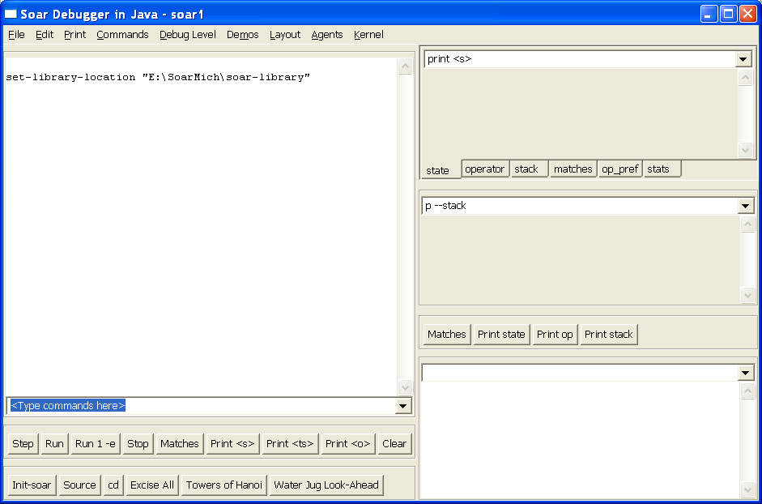

The window on the left side is the main trace window. As Soar executes, debug information is streamed to this window.

On the right are a series of other utility windows which we’ll discuss later.

To get things going load the towers of Hanoi demo. This can be done by either pressing the “towers of Hanoi” button or from the “Demos” menu. Then type “run 20” into the line marked “<Type commands here>” (shown in blue above).

You should be rewarded with a display like this:

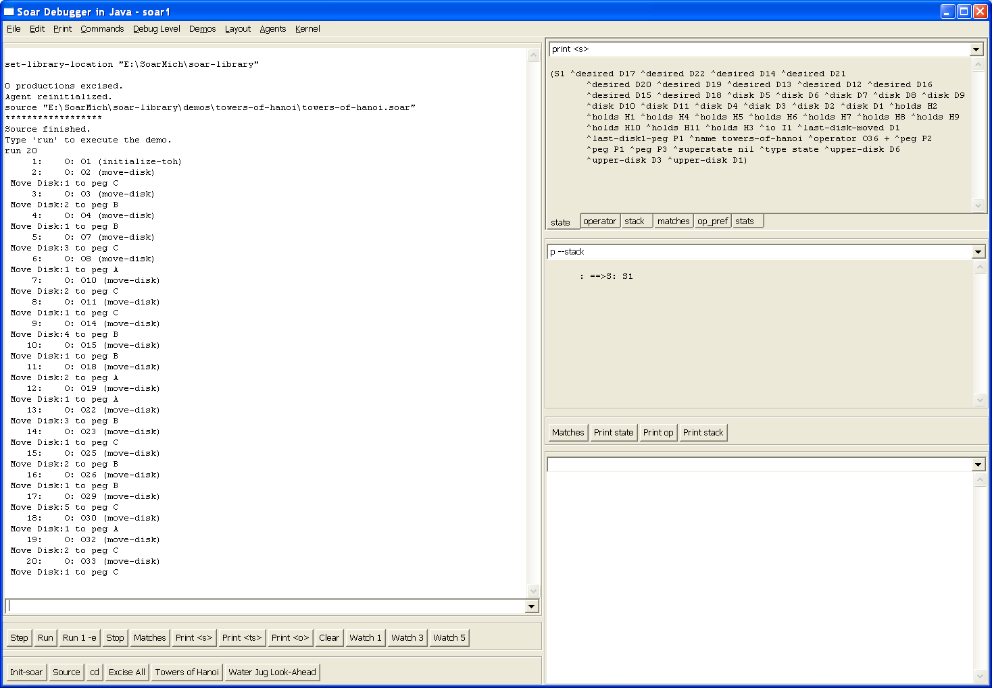

This is hard to read but the trace window on the left shows the series of operators that have just fired during the course of the first 20 decisions. You should also have noticed that at the end of the run the windows on the right updated automatically to print the current state and stack. In fact, they are just issuing the command typed at the top of the window, so you can customize the window to print any values you’d like to see at the end of a run. Because the windows only update after the run completes there is no performance hit from these windows during a run.

The different tabbed windows at the top right of the display (state, operator, stack etc.) show examples of some values you might find useful. In a real debugging session you can use this simple mechanism to watch a particular part of working memory (e.g. printing the input link) while you step forward.

The default layout that you started with uses a tree view for the main trace window. To see this in action press the “watch 5” button and then type “run 20” again at the command prompt.

This should result in a display like this:

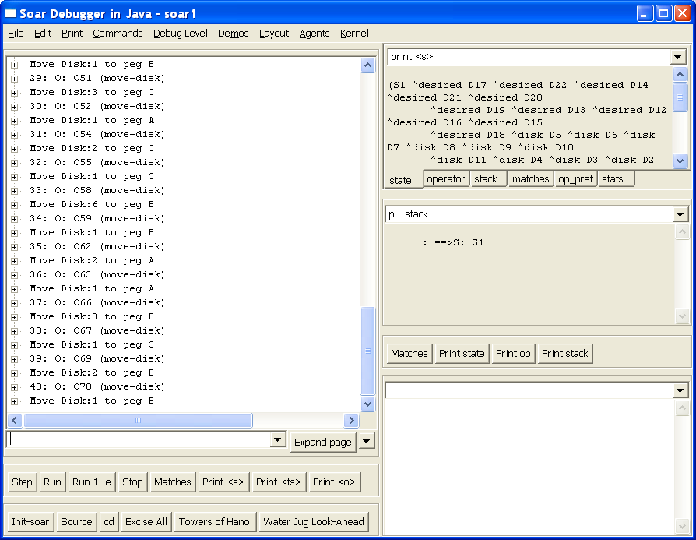

The trace looks similar, but doing the obvious thing of expanding the tree nodes will reveal the detailed trace information collected during the run:

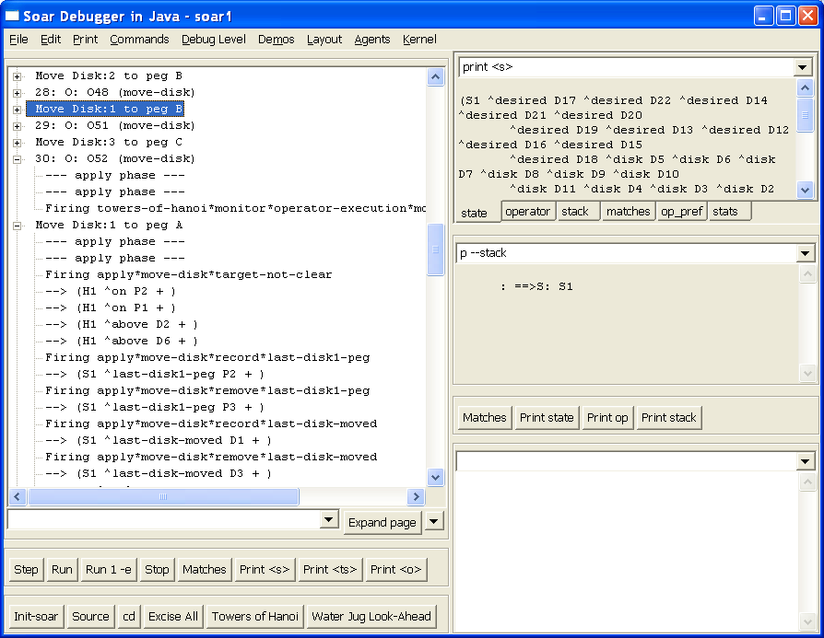
There are some limitations with this tree view that we hope to improve in future versions (most notably you can only copy and paste text from a single line at a time and the performance is still not as high as we would like).

You can also expand all of the trace information using the “expand page” button or the drop down menu next to it.

The window in the lower right is something of a scratch pad. Commands typed at the top of this window (e.g. print s4) are printed below and just stay there. This helps solve the problem of output “scrolling off the top” of the main trace window.

Agents
The debugger can be used with multiple agents. To see this, select “Agents | Create Agent – New Window” and you’ll get a new top level window for agent “soar2”.

If you load another demo here (e.g. “Water Jug Demo”) and then type “run 20” you will see both sets of windows updating as both agents run.

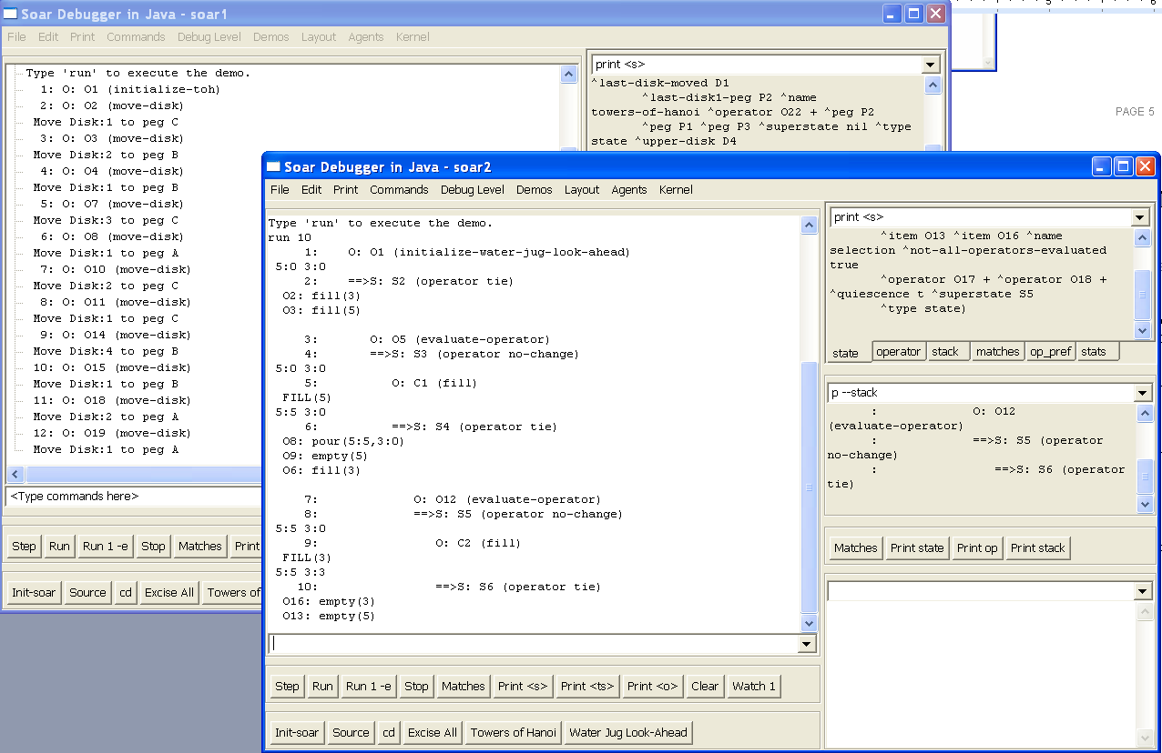

The relationship between a top level debugger window (a frame) and the agent is pretty loose. For instance, we can switch the second window to observe the first agent (Agent | Select Agent and choose “soar1”). This gives you two windows pointed at the same agent. Probably not very useful, but it illustrates the point that the debugger windows and the agent are separate entities.

The Agent menu also allows you to create a new agent without a new window or create a new window without a new agent. You also should be aware that closing a debugger window does not delete the agent. If you want to delete an agent you must do so explicitly from the Agent menu.

Kernels
When you launch the debugger it creates a new instance of the Soar kernel as part of the debugger’s process. We refer to this as a “local” kernel.

You can also connect the debugger to a “remote” kernel which is running inside another process or even on another machine.

All Soar kernels (using the SML interface) support this sort of remote connection automatically, so we can see an example of this by using two debuggers (with a little care). To see this launch a second instance of the debugger so you have two running. You’ll need to keep track of which debugger was launched first.

On the debugger launched second choose “Kernel | Connect to remote Soar”. You’ll get a warning that there’s a local kernel running. Say “OK” to shut that down. You’ll see a dialog like this:

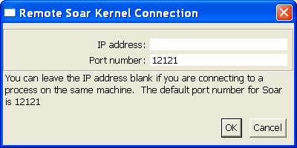

This allows you to enter an IP address (for a truly remote machine) or a different port number (which requires a change to the kernel you are connecting to). For this example and in almost all cases you’ll want to leave these as the default settings.

Clicking ok connects this debugger to the remote kernel and selects an agent to focus on. (You could use the Agent menu to select which agent if there were multiple agents running in this kernel).

Now you can type commands into either debugger (e.g. type “run 10”) and you’ll see both windows update.

Obviously, the idea isn’t to connect two debuggers together, but to connect to simulations. This sort of connecting and disconnecting allows us to build simulations that run a local or embedded kernel (for maximum performance) and then connect a debugger to them to see what they are doing.

There’s nothing special about the way the debugger is doing this. All instances of an SML kernel support this sort of remote connecting, so it’s also possible (by changing a single line of code) to build a simulation that connects to a remote debugger instance and so on. Also multiple tools (or clients) can connect to a single kernel at the same time, allowing different types of debuggers to be connected to a simulation as necessary.

Customizing the debugger

Layouts
A particular arrangement of windows within the debugger is referred to as a layout. The Layout menu allows you to select from two basic window layouts based around a text trace window or a tree trace window.

You can also create your own preferred window layout. To start this process, right click on a window in the debugger. The context menu will either look like this:

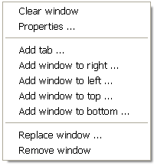

Or it will have offer this menu as a “Window” pop out on the context menu like this:

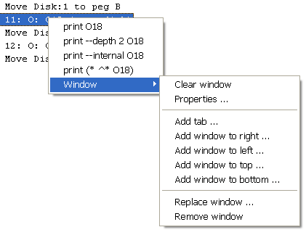

This window menu allows you to customize the collection of windows by adding, removing or replacing windows. The types of windows you can add is based on the list of modules loaded into the debugger and should grow in time. Right now there are just five:

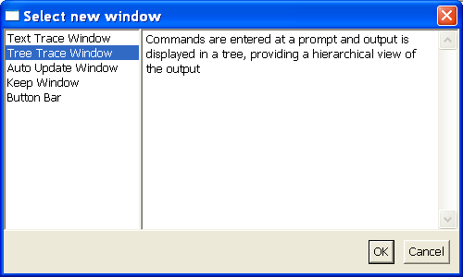

Creating a new layout can take a while as we don’t yet have a “Move Window” option. This is something to be added in the future. Once you’ve created a new layout it will be saved automatically as your layout for the future (technically it’s the layout of the last frame window closed if you’re using multiple agent windows).

You can also share window layouts that you find useful by saving the layout file (a DLF file) or loading other layout files. This is offered through both the File menu and the Layout menu.

These DLF files are pretty simple XML files, so it’s sometimes easier to adjust the layout by just editing this file directly (e.g. to move windows around in the display).

Properties
The window right-click menu from above includes a “Properties…” item which allows you to bring up a dialog and adjust certain properties for a particular window.

For instance, right clicking and choosing “Properties” for one of the automatically updating windows (top right in the default layout) brings up these properties:

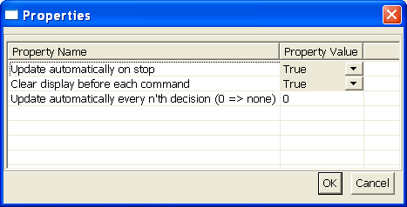

By adjusting these properties you can allow the results to collect in the window rather than being cleared each time a command is executed or you can have a window that updates every 10th decision during a run rather than just at the end of a run.

Known limitations
The most obvious limitations are related to the tree view. There’s no ability to select multiple lines of text in this view and copy/paste them elsewhere. Also there’s no ability to paste a multiple line object (like a production) into any of the windows.

Also the modules we’ve so far implemented are all fairly basic – with simple text entry of commands and text displays of the output.

The great saving grace of this debugger is that if you know Java and want to spend a little time, you can write your own module to add to the framework and build the debugger you wished you had. If you find yourself wanting to do this, please drop us a line (soar-sml-list@lists.sourceforge.net) before you start coding and we’ll help you along and hopefully share in the results.

